**Onboarding Task 1 (BI)**

Task 1.a Display a list of all property names and their property id’s for

Owner Id: 1426.

Solution:

SELECT p.[Name] AS PropertyName

, p.Id AS PropertyID

FROM OwnerProperty AS op

INNER JOIN Property AS p ON op.PropertyId=p.Id

WHERE op.OwnerId=1426;

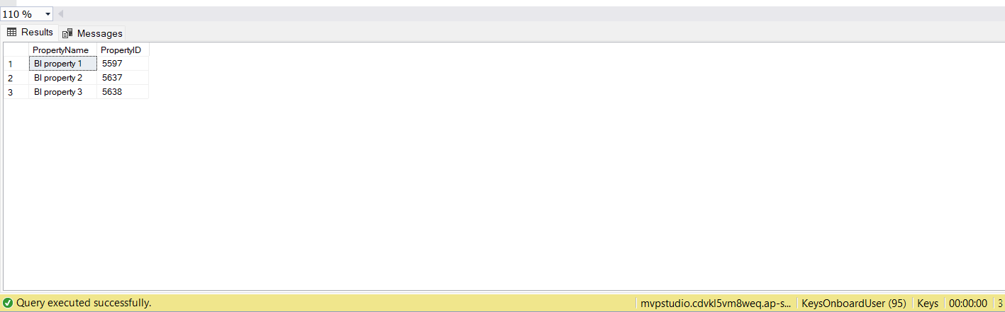

Task 1.b Display the current home value for each property in question a)

select A.id, B.propertyid, B.ownerid, c.value from dbo.property A

left join dbo.[OwnerProperty] B

on A.id=b.propertyid

left join dbo.propertyhomevalue C

on A.id=c.propertyid

and c.IsActive=1

where B.ownerid=1426;

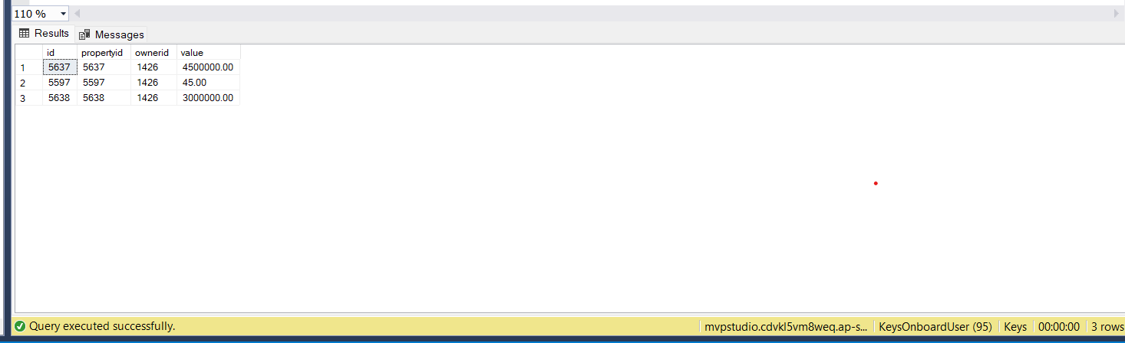

Task 1.c For each property in question a), return the following: i) Using rental payment amount, rental payment frequency, tenant start date and tenant end date to write a query that returns the sum of all payments from start date to end date.

SELECT tp.PropertyId,

CASE

WHEN PaymentFrequencyId = 1 THEN (DATEDIFF(Week,tP.StartDate,tp.EndDate)*PaymentAmount)

WHEN PaymentFrequencyId = 2 THEN (DATEDIFF(Week,tp.StartDate ,tp.EndDate)*PaymentAmount /2)

WHEN PaymentFrequencyId = 3 THEN (DATEDIFF(Week,tp.StartDate ,tp.EndDate)*12*PaymentAmount /52)

END AS SumOfAllPayments

FROM TenantProperty tp

WHERE tp.PropertyId IN('5597', '5637', '5638');

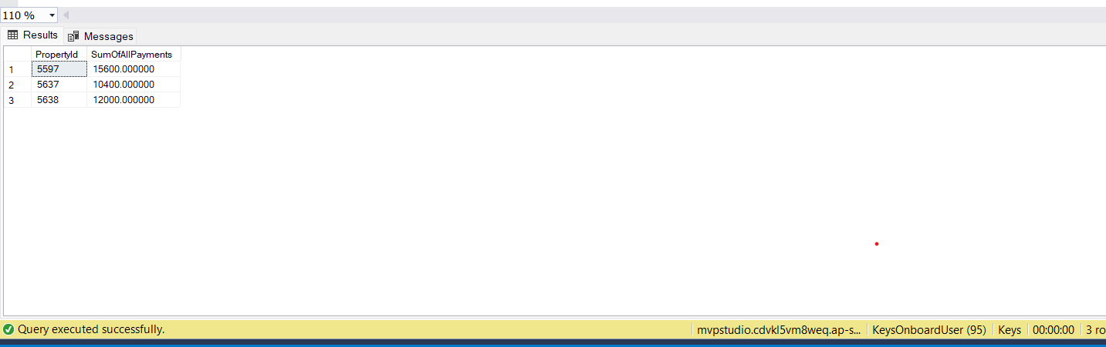

Task 1.c For each property in question a), return the following: ii) Display the yield.

SELECT p.[Name] AS PropertyName

, p.Id AS PropertyID

, phv.[Value] AS HomeValue

, (

(

(CASE

WHEN trt.[Name] ='Weekly' THEN (DATEDIFF(wk,tp.StartDate, tp.EndDate)*prp.Amount)

WHEN trt.[Name] ='Fortnightly' THEN ((DATEDIFF(wk,tp.StartDate, tp.EndDate)/2)*prp.Amount)

ELSE (DATEDIFF(m,tp.StartDate, tp.EndDate)*prp.Amount)

END

)-ISNULL(SUM(pe.Amount),0)

)/phv.[Value]

)*100 AS Yield

, trt.[Name] AS RentalPaymentFrequency

, prp.Amount AS RentalPaymentAmount

, tp.StartDate AS TenantStartDate

, tp.EndDate AS TenantEndDate

FROM Property AS p

INNER JOIN OwnerProperty AS op ON p.Id=op.PropertyId

INNER JOIN PropertyRentalPayment AS prp ON p.Id=prp.PropertyId

INNER JOIN TargetRentType AS trt ON prp.FrequencyType=trt.Id

INNER JOIN TenantProperty AS tp ON p.Id=tp.PropertyId

INNER JOIN PropertyHomeValue AS phv ON p.Id=phv.PropertyId

LEFT JOIN PropertyExpense AS pe ON p.Id=pe.PropertyId

WHERE op.OwnerId=1426 AND phv.IsActive=1

GROUP BY p.[Name],p.Id,phv.[Value],trt.[Name],prp.Amount,tp.StartDate,tp.EndDate;

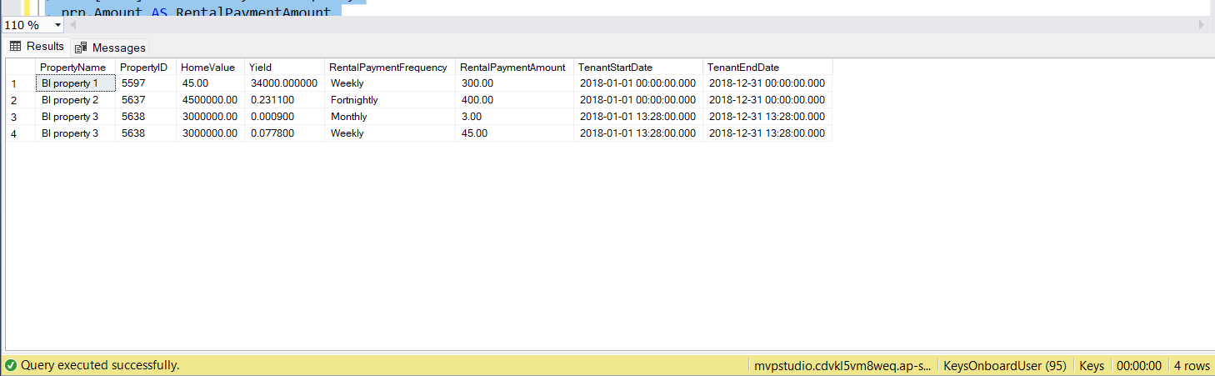

Task 1.d. Display all the jobs available in the marketplace (jobs that owners have advertised for service suppliers)

SELECT j.Id AS JobID

, j.PropertyId

, j.OwnerId

, j.JobDescription

, Count(jm.Id) AS No_Of_JobMedia

FROM Job AS j

INNER JOIN JobMedia AS jm ON j.Id=jm.JobId

WHERE jm.IsActive=1

GROUP BY j.Id, j.PropertyId, j.OwnerId, j.JobDescription

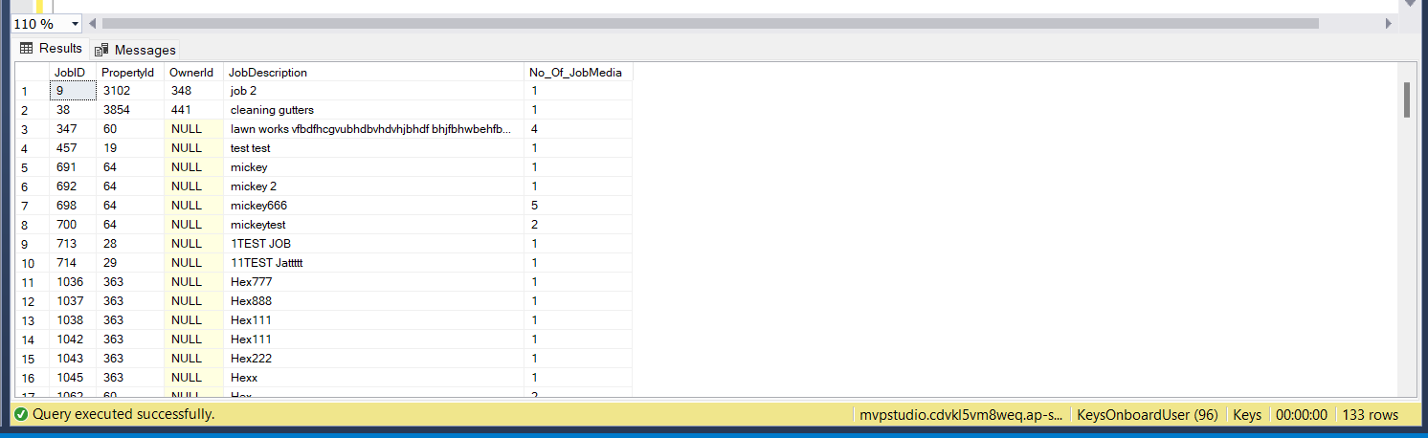

Task 1.e. Display all property names, current tenants first and last names and rental payments per week/ fortnight/month for the properties in question a).

SELECT P.Name as PropertyName, CONCAT(FirstName,' ',LastName)as CurrentTenantName,tp.paymentAmount AS RentalPayments,tpf.Name as PaymentFrequency

FROM OwnerProperty op

INNER JOIN TenantProperty tp ON op.PropertyId =tp.PropertyId

INNER JOIN TenantPaymentFrequencies tpf ON tpf.Id = tp.PaymentFrequencyId

INNER JOIN Property p ON op.Id = p.Id

INNER JOIN Person per ON op.Id= per.Id

WHERE op.PropertyId IN('5597', '5637', '5638') AND op.OwnerId=1426;

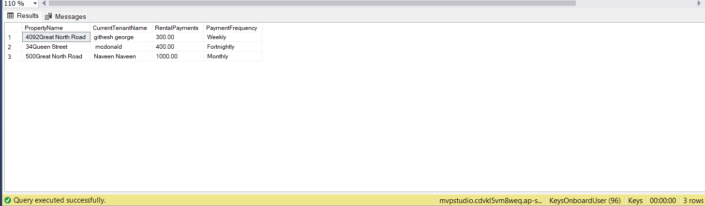

Use Report Builder or Visual Studio (SSRS) to develop the following report:

2.) Query For Report

SELECT FirstName AS OwnerName,

CONCAT(Street, ' ' ,Suburb, ' ' ,City, ' ' ,PostCode) AS Address,

CONCAT(Bedroom,' Bedroom , ',Bathroom,' Bathroom') AS PropertyDetails,

pe.Amount,pe.Description as Expense,Format(pe.Date,'dd MMM yyyy') AS Date,

CASE

WHEN PaymentFrequencyId = 1 THEN CONCAT('$',CAST(PaymentAmount AS int),'Per Week')

WHEN PaymentFrequencyId = 2 THEN CONCAT('$',CAST(PaymentAmount/2 AS int),'Per Week')

WHEN PaymentFrequencyId = 3 THEN CONCAT('$',CAST(PaymentAmount/4 AS int),'Per Week')

END AS RentalPayment

FROM Property p

INNER JOIN OwnerProperty op

ON p.Id =op.PropertyId

INNER JOIN Person per

ON op.OwnerId= per.Id

INNER JOIN Address Address

ON p.AddressId =Address.AddressId

INNER JOIN TenantProperty tp

ON p.Id = tp.PropertyId

INNER JOIN TenantPaymentFrequencies tpf

ON tp.paymentFrequencyId=tpf.Id

INNER JOIN PropertyExpense pe ON p.Id=pe.PropertyId

WHERE OwnerId=1480;

